Local Enhancement Programme 2024
Women’s Fund - Application Form

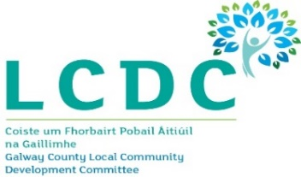
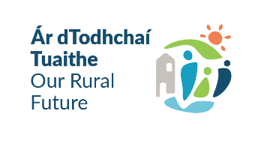
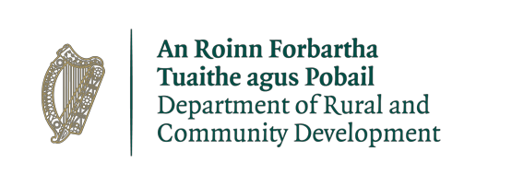
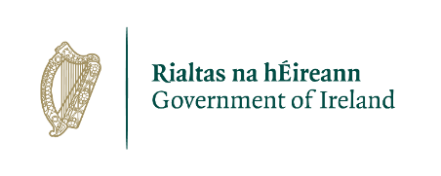

WOMEN’S GROUP NAME:

Please confirm you have enclosed the following:

Fully completed and signed Application Form | Yes ☐
Copy of most recent Bank / Credit Union Statement | Yes ☐
Copy of Public Liability Insurance Policy | Yes ☐
1 quotation for each expenditure item under €3,000 or 3 quotations for each item over €3,000 | Yes ☐

You may submit your completed application by ONE of the following methods:

By e-mail to: communitygrants@galwaycoco.ie (this is our preferred method of receipt – please sign the form first, then scan & e-mail it with all supporting documentation).

OR

By post to: COMMUNITY GRANTS
Rural & Community Development Department
Galway County Council, County Hall
Prospect Hill
Galway H91 H6KX.

The closing date for receipt of completed application forms is
Tuesday 27th February 2024

All questions on this form must be answered.

INCOMPLETE OR LATE APPLICATIONS WILL NOT BE CONSIDERED.

Department of Rural and Community Development
Local Enhancement Programme 2024
Ring-fenced fund for Women’s Groups

The Department of Rural and Community Development (“the Department”) has allocated funding of €1 million to support Women’s Groups across Ireland (€30,896.17 for County Galway). This is a ring-fenced fund under the Local Enhancement Programme 2024. The application process is being administered by Local Community Development Committees (LCDCs). Applications for this funding can be made on this application form. Women’s Groups are eligible to apply, once they meet the LCDC’s qualifying criteria.

It envisaged that this funding would, in general, be allocated in a relatively equal manner across Women’s Groups that submit valid applications. Women’s Groups can also apply to the General Fund, provided their total request for funding under the Local Enhancement Programme does not exceed the maximum amount set by the LCDC for any Group/Organisation of €5,000.

TERMS AND CONDITIONS
- The ring-fenced funding under the Local Enhancement Programme will support Women’s Groups, particularly in disadvantaged areas, to carry out necessary repairs and improvements to their facilities and purchase equipment.
- This is a capital funding scheme. The scheme does not provide funding for the pay or employment of staff, or towards current ‘operating’ costs such as utility bills, etc.
- The information supplied by the applicant Women’s Group must be accurate and complete.
- Inaccurate or incomplete information may lead to disqualification and/or the repayment of any grant made.
- All information provided in respect of the application for a grant will be held electronically. The Department reserves the right to publish a list of all grants awarded on its website.
- The Freedom of Information Act applies to all records held by the Department and Local Authorities, including applications received and any additional correspondence related to the application.
- The application must be signed by the Chairperson, Secretary or Treasurer of the Women’s Group.
- It is the responsibility of each organisation to ensure that it has proper procedures and policies in place including appropriate insurance where relevant.
- Applications must be on the application form for 2024.
- Evidence of expenditure, receipts /invoices must be retained and provided to the LCDC, the Department of Rural and Community Development, the relevant local authority or any agent acting on their behalf if requested.
- Grant monies must be expended and drawn down from the LCDC by 31st October 2024.
- The Department of Rural and Community Development’s contribution must be publicly acknowledged in all materials associated with the purpose of the grant.
- Generally no third party or intermediary applications will be considered.
- Applications by post should use the correct value of postage stamps and allow sufficient time to ensure delivery not later than the closing date of 27th February 2024. Claims that any application form has been lost or delayed in the post will not be considered, unless applicants have a Post Office Certificate of Posting in support of such claims.
- Breaches of the terms and conditions of the grants scheme may result in sanctions including disbarment from future grant applications.
- In order to process your application it may be necessary for Galway County Council to collect personal data from you. Such information will be processed in line with the Local Authority’s privacy statement which is available to view on www.galway.ie

SECTION 1: YOUR GROUP/ORGANISATION DETAILS
Name of Group / Organisation:

Address:

Eircode:

Website:

Contact names for Correspondence:
(Please provide 2 names)

Role in Group / Organisation:

Telephone number:

E-mail:

Is your Group registered with the PPN? If NO, please consider registering with the PPN.  https://www.galwaycountyppn.ie/registration-form/ | Yes ☐ Reg. No. ___________ No ☐
Year Group/Organisation established:

Please provide a description of your Women’s Group, including information on the number of members, the organisational structure of your group, your group’s aims, whether there is any criteria for membership, the main focus of the activities of your group, etc.

Charitable Status Number (if applicable)
Tax Reference Number (if applicable)
Tax Clearance Access Number (if applicable)

Have you received funding under any capital grant schemes from 2022 to current date, i.e., grants from Government Departments or LEADER? YES ☐ NO ☐
If YES please give details below
Name of scheme | Funding organisation | Amount received | Purpose of Grant

Is your organisation affiliated or connected to any relevant local regional or national body? If yes, please give details: | Yes ☐ No ☐
Do you receive core funding from any other local, regional, or national Organisation / Body? If YES, please give details:
No. of Committee Members:  No. of Volunteers:  No. of Paid Staff: | Full-Time: | Part-Time:
 | Full-Time: | Part-Time:
 | Full-Time: | Part-Time:
How many people does your organisation support?

Do you charge membership fees?  If you answer ‘yes’, what do you charge? | Yes ☐ No ☐ €
How does your Group/Organisation link in with other Organisations in your area?

Please input exact location (X-Y co-ordinates) of where the proposed project will be based:
If this is not completed, your application will be deemed ineligible.

Y ITM
X ITM

This information is required in ITM format. The simple guide we have provided with this form will show you how to find these on https://irish.gridreferencefinder.com/

SECTION 2: PROJECT DETAILS & FUNDING REQUEST

How much funding are you applying for? | €

Describe the capital project/purchase of equipment proposed, and the level of need:

Please breakdown expenditure on the equipment/project for which you are requesting funding. Please ensure you provide 1 estimate/quote for each expenditure item up to €3,000, and 3 estimates/quotations for any expenditure item/project over €3,000. Lack of this supporting documentation will render your application ineligible.
Expenditure Item(s): | Amount
 | €
 | €
 | €
 | €
Total Expenditure: | €

Is this amount a partial or total project cost? If partial, give the estimated total project cost. To be eligible for funding under this Programme, you must show where you will source any shortfall of funding – please provide these details below: | Partial ☐ _________  Total ☐ _________
Source | Amount of funding
 | €

If funding is for a construction or renovation project, all grant monies must be expended and drawn down from the LCDC by 31st October 2024:

When will your project begin?

When will your project be completed?

Are all relevant permissions in place (e.g., planning, written consent from landowner/property owner if your project involves the development of a property)?  If YES please provide the details: | Not applicable ☐ YES ☐ NO ☐
Is this part of a phased development and/or linked with (or funded by) other schemes operated by Government Departments or the Local Authority?  If YES please provide the details: | Not applicable ☐ YES ☐ NO ☐

SECTION 3: ACKNOWLEDGEMENT AND DECLARATION

If successful, please state how your Group proposes to publicly acknowledge the financial contribution from the Department / Galway County Council / LCDC?
Note: Depending on the amount being applied for, this could be as simple as including an acknowledgement on notices/signs, or in any newsletters that are being produced locally.

On behalf of our Group/Organisation, I confirm that:
- I declare that the information given in this form is correct.
- I confirm I have read and fully understand the Terms and Conditions of this Programme (see page 2 of this form).
- I confirm that this grant application is submitted in acceptance of and compliance with the Terms and Conditions.
- I confirm that the Women’s Group does not have the funding to undertake the work/project without this grant aid or alternatively that with the grant the Group will now undertake a larger project which they otherwise would not be able to afford.
- I confirm that the applicant Group is tax compliant (if tax registered).

This Declaration must be signed by Chairperson, Secretary or Treasurer, on behalf of Applicant Group:

Name (in block capitals):
Signed:
Position in Applicant Organisation:

Date:

The Department operates the Local Enhancement Programme through the Local Community Development Committees (LCDCs). It is a grant programme that provides funding to enhance facilities in disadvantaged areas. The Department committed to funding of €6 million for this programme. The €1 million fund which is ring-fenced for Women’s Groups is part of the €6 million.

